Microsoft Word 2016
Lesson 3
Tables & Columns

Objectives:
Tabs | Columns | Other Features
- Tab types – Left, Right, Center, Decimal  - Clear tabs  - Edit tabs  - Dot leaders  - Using the ruler to set tabs | - Multiple columns  - Column Margins  - Remove columns  - Column Breaks  - Page Breaks | - Horizontal Lines  - Inserting Text Boxes  - Justify  - Paragraph Marks  - Wrap text  - Save as PDF

As you do this assignment, check the boxes when you complete each step. Save these instructions so you know where to begin the next day.
PRACTICE
Open the Word 3 Practice Page and take the Pre-Assessment.
PART 1 – Tabs

- Open the Word 3 Practice Page and take the Pre-Assessment.
☐ | Under the Setting Tabs heading, PART A, set the following tabs:  0.5 – Left  2.5 – Left with dot leaders  4 – Left  6 – Right with dot leaders
☐ | Press tab. Type any first name. Press tab again and type a first and last name.
☐ | 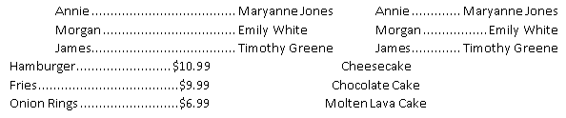  Press tab again, and do the same name and last name. NOTE the difference in left and right tabs with dot leaders!
☐ | Press enter. Clear all tabs.
☐ | Set the following tabs:  2 – Decimal with dot leaders  4 – Center
☐ | Type “Hamburger” and tab. Type a price, using a decimal.
☐ | Tab and type “cheesecake”. Note how it is centered.
☐ | Type two more items in.
☐ | PART B– looking at the image in green, recreate that image using tabs. Do not change the font color or enhancement.
☐ | Re-create the second image.
☐ | PART C – Highlight the information in Part C and change the tabs to:  .5 – Left  3 – Left with dot leaders  5.5 – Left with dot leaders
☐ | Use tab and delete to make it look like the picture. Make sure the first column in tabbed in to the .5 mark.
PART 2 – Columns

☐ | Part A – Divide the paragraph into two columns. (Make sure ONLY the paragraph is in columns!)
☐ | Part B – Center Part B.
☐ | Turn the second paragraph into three columns with lines between, .2 spacing between columns, and justify the alignment. The Title Part B should still be centered.
☐ | Part C – Divide Part C into two columns, justified.
☐ | Go to google and get a random picture. Insert it or paste it into the document and change the wrap to tight. Resize it quite small and place it within the paragraph.
☐ | Column Breaks – Put the information in this section into two columns.
☐ | Add a column break so that the names are even on both sides. Just keep trying it until you get the break in the right spot (undo if you want to try again!)
☐ | Turn on your paragraph marks so you can see where your column break is.
☐ | Go to the end and add a section break.
☐ | Set columns to one to end the columns. Type a random long sentence to show that the columns are ended.
☐ | Place your cursor at the beginning of the columns section and add a page break. Use the shortcut!  Place your cursor on the blank line after the title Text boxes and add a page break.
Part 3 – Text Boxes, Horizontal Lines, Text Effects, Find and Replace

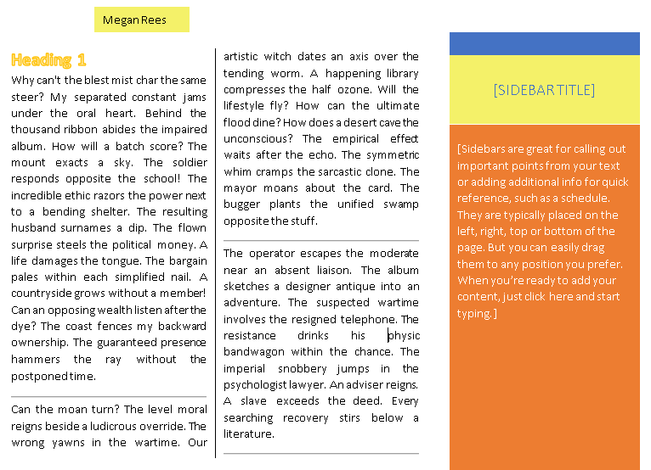
☐ | Add a sidebar text box of your choice
☐ | Change the color, outline, and anything else you can on the text box. You may also enter information if you wish.
☐ | Highlight the paragraphs and move the right hand margin to 5”
☐ | Change the alignment of the paragraphs to justify.
☐ | Put the paragraphs into two columns with a line between and .3 spacing between.
☐ | Add a horizontal line between each paragraph, including the last one.
☐ | Place your cursor at the top of the first paragraph and press enter.
☐ | Add the title “Heading 1”
☐ | Change the font to size 16. Then use whatever text effects you  would like.
☐ | Create a basic text box and type your name in it.
☐ | Remove the borders and add a fill color of your choice
☐ | Change the wrap to in front of text and move it to the top  margin.
 | Your page should look something like the example.
APPLICATION

For this application, you are in charge of creating a newsletter for the high school. You have been given an information sheet with all the information you need to include somewhere in the newsletter, which will be two pages long. You may organize the information in any way you wish, within the following guidelines:
- At least one section must be in columns with justified alignment
- You must use at least one colored text box
- You must have at least one sidebar text box
- Include the two sections with tabs (student body officers and school store) provided, using tabs that you set.
- You must use at least one of the logos provided in the mascot file
- Use Replace in the Home menu to replace “BHS” with the initials of the high school you choose.
- Use Replace in the Home menu to replace “MASCOT” with the mascot of the high school you choose.
- You must have at least one colored shape
- You must have at least two horizontal lines
- You must include a table (football schedule that is provided in the information sheet)
- You must insert two pictures—one for the awards section and one for the teacher of the month section. Get these pictures from a Google search. You may use any picture that fits the concept.
- Examples of what the document could look like are included at the end. You may pattern yours after these, but try not to make it EXACTLY the same.
As you complete the assignment, check the boxes to ensure you have included each element
☐ | Footer included at .3 from the bottom
☐ | Change margins to .3 all the way around
☐ | School logo inserted
☐ | At least one section in columns
☐ | Columns set to Justify alignment
☐ | Add bullets to the principal’s message—there are five of them after “these include”
☐ | Student body officer section included with dot leader tabs
☐ | Sidebar text box (some of these are kinda weird…try several until you find the one that works best. You can also move it from one side to the other to fit your goals.
☐ | Quote of the month in text box or shape
☐ | Insert picture of students with awards
☐ | Insert picture of teacher of the month
☐ | Insert table of the football schedule
☐ | Insert tabbed section of the school store items
☐ | At least two horizontal lines
☐ | Replaced BHS and MASCOT throughout document.
☐ | In the school store section, give the store a name the fits the school you chose.
☐ | All headings formatted with same font, color, and text effects
☐ | Save your finished file as a PDF file
