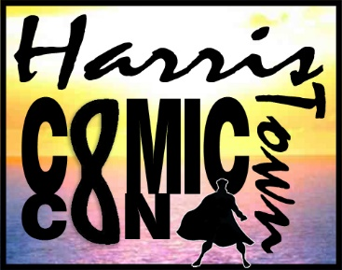
Microsoft Office Word 2013
Lesson 1
Poster

- Open a blank page in Word.
  - Save the document with Word 3 and your initials.
  - Add a FOOTER with your name, period, and Filename (quickparts).
- Margins & Orientation
IN THIS LESSON
- Margins
- Orientation
- Page borders
- Word Art
- Text Effects
- Text Wrapping
- Shapes
- Tables vs. Tabs
- Merging cells
- Shading
- Setting tabs
- Text Boxes

  - Change the margins to .5 on all sides
  - Change the orientation to landscape
- Page Border
  - In the Design tab, go to page borders
  - Choose either an art border or a line border
    - If you do an art border, change the thickness to 12 pt—you don’t want it too thick.
    - You may change the color if you wish.
- Word Art vs. Text Effects
  - At the top of the page, type “Harristown”
  - Press enter and type “4th Annual” and press enter
  - Highlight both lines and center them.
  - Change Harristown to size 24, and 4th annual to 18.
  - Choose a font for both words—pick a clear, easily readable and bold font.
  - Highlight Harristown again and use the text effects to alter the look to your taste. Just avoid using the “reflection” section because it will take up too much space.
  - After 4th Annual, press enter and go to Insert>Word Art
  - Create WordArt that reads “COMICON” in all caps. Make it size 72—or smaller depending on the font you use.
  - Under the WordArt, type “Harristown Convention Center” and format paint it to look like “4th Annual.”
  - Make sure there are no extra lines between the Comiccon title and the convention center text.
- Insert Picture
  - Insert the Comicon logo from the Lesson 3 file.
  - Change the font to In Front of Text and place it in the empty space to the left of the title.
- Insert Shape
  - Insert a square shape that is roughly the same size as the logo, and place on the right side of the title.
    - Remove the outline
    - Change the color style as you plase
    - Type “April 23, 2016” into the shape.
    - Change the font to the same one you used in your title, and the size to about size 24 (depending on font you chose.)
    - Add a glow to the shape
- Table
  - Press enter and clear all formatting
  - Create the table below. Be sure to merge the cells correctly.
  - In the Time section, make sure to space after 1:00 so that the colons line up all the way down.
  - Make the font size of the inside text size 10, and the font arial.
  - The titles are all size 14, an the times are size 10.
  - Shading:
    - Shade all guest speakers the same color.
    - Shade all Panels another color
    - Shade all photo ops a third color
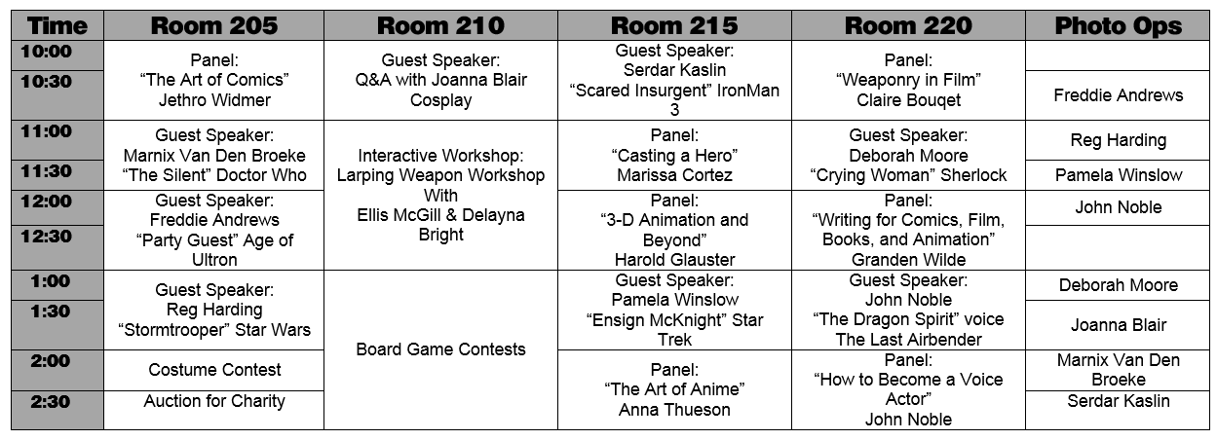
    - Shade the workshop and the board came contests a fourth color.
- Tabs
  - After the table, press the Clear Formatting button to clear out anything that may be lingering.
  - Set the following tabs:
    - Center tab at 1.75
    - Center tab at 8
  - Press tab and type “Photograph Pricing”
    - Press tab and type “Featured Vendors”
    - Format both titles the same as “Harristown Convention Center.”
    - Press enter.
  - Clear all formatting.
  - Set the following tabs:
    - Left tab at .5
    - Decimal tab with dot leaders at 3
    - Left tab at 6.3
    - Left tab at 8.25
    - Enter the information as shown.
    - *Remember—when entering tabs, enter ALL information HORIZONTALLY, not VERTICALLY.
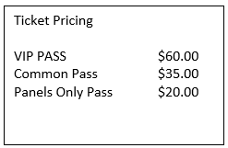
- Text Box
  - Insert a simple text box and place it in the empty space between the tabs.
    - Resize it to fit.
    - Change the wrap to In Front of Text
  - In the box, type the information show on the right.
  - Make sure all tabs line up.
  - Center the title, size 14, and the font you’ve been using for all your titles.
  - Change the shading of the text box to a custom gradient of your own creation.
  - Add a thick colored border to the box.
  - Add a glow to the box.
  - Add a bevel to the box.
- Save and Print
  - If you’ve done it correctly, it should easily fit on one page.
    - If not, remove any extra lines that may be adding to the length and check your font sizes.
    - If there are extra blank pages, go to the last line at the bottom of the first page and press delete until all blank pages are gone.
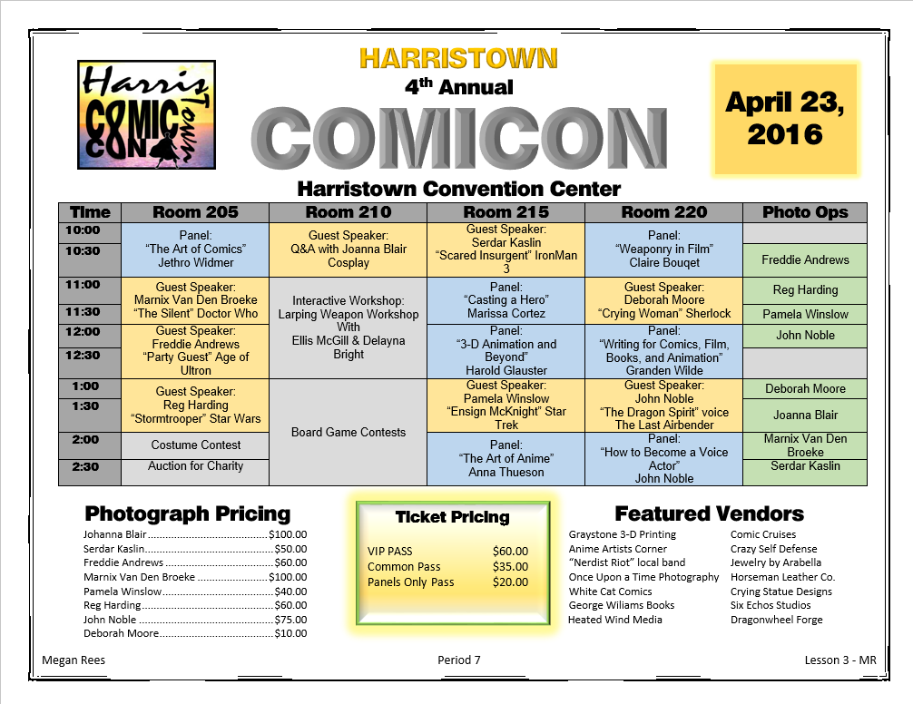
  - Save the file again and print.

