Microsoft Office Excel 2013
Lesson 3
Math & Text Functions

- Open the Excel 3 Starter.
  - Save the document with Excel 3 and your initials.
  - Add a header with your name, filename, and period.
- Part 1: Simple Functions – Click on the Part 1 Tab
IN THIS LESSON
- MATH FUNCTIONS:
  - Sum
  - Average
  - Count
  - Max
  - Min
  - Counta
  - Countif
- TEXT FUNCTIONS
  - Left
  - Right
  - Concatenate
  - Proper
  - Lower
  - Upper
  - 1A: SUM
    - Use the SUM function to sum the numbers in A4:A12.
    - DO NOT use autofill—do the formula 4 times, once for each column.
    - Check your Score Sheet to be sure that you got a point for this section.
  - Do the same for Parts B-D, using the Average, Min, and Max functions.
  - Part 1E: COUNT
    - Highlight F4-F55 to calculate how many numbers are in the list.
  - Part 1F: COUNTA
    - Use the COUNTA function to count text.
    - Count the number of students listed in column H. The answer should appear in I49.
  - Part1G: COUNTIF
    - Use the COUNTIF function to calculate:
      - How many male vs. female
      - How many in each of the three grades
      - How many in each of the five color teams.
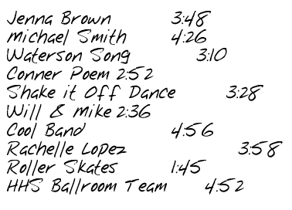
        - Remember to use “” around text you are counting, but not numbers.
    - Check your score sheet to see if you received a point.
- Part 2: Practical Uses for Sum, Average, Max, and Min
  - 2A: Adding Time
    - In C5:C14, enter the times as listed to the right.
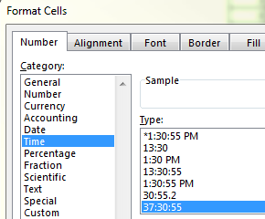
    - Before entering—change the format to time!
      - Make sure to change the formatting of C5:C15 to the correct format—shown left.
      - When entering, enter a “0:03:48” in order for it to format correctly.
    - Sum the total in C15.
    - Check the score sheet to see if you got it right.
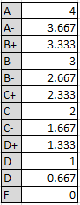
  - 2B: Figuring GPA with Averages
    - Using the figure to the right, enter the numerical value for each grade for each quarter.
    - AVERAGE each individual quarter’s grades.
    - In J12, AVERAGE each of the quarter’s GPA to figure the cumulative GPA.
      - =AVERAGE(H11,J11,L11,N11)
    - In H11, J11, L11, N11 and J12, change the format to 2 decimal places.
      - Hint: You can use the CTRL key to do it all at once!
  - 2C: MAX, MIN, AVERAGE and SUM in a Judging Sheet
    - In column J, find the average for each students score in singing, dancing and acting.
      - Autofill down.
    - In column K, find the MAX score for each student.
      - You must enter the function by hand—using Autosum will not work because you do not want to include the numbers in column J.
    - In column L, find the MIN score for each student.
    - In column M, find the total score for each student.
    - In J38, find the average of all the scores in column J. Do the average fro the min, max, and total columns as well.
    - Sort the list by total score, with the highest score at the top.
      - Check your score sheet.
- Part 3: Combining Formulas & Functions
  - Change the format in C6-C33 to %.
    - Change the format to 1 decimal place.
FORMULAS:
  - In B3, enter the start weight by typing in =B6.
  - In D3, enter any date as the start date.
  - In G3, enter the end weight by typing in =B33.
  - In A6, enter the start date by typing in =D3.
  - In A7, enter the next week’s date by typing in =A6+7 (as in 7 days.)
    - Highlight A7 and autofill down to fill in the rest of the dates.
    - Change the start date in D3 and watch what happens.
  - In G7, figure out the amount of weight lost in the first week.
    - Autofill down.
  - In D34, figure out the amount of inches lost around the waist.
  - In E34, figure out the amount of inches lost around the hips.
  - In F34, figure out the amount of inches lost around the chest.
  - In C36, figure out the total amount of pounds lost.
  - In C37, figure out the total amount of inches lost.
  - In C38, figure out the average amount of weight lost per week. You will need column G for this.
    - Change the number format to 1 decimal place.
  - In C39, figure out the highest amount lost in one week.
    - Change the number format to 1 decimal place.
  - In C40, figure out the lowest amount lost in one week.
  - In C41, figure out the % of body fat lost. (subtract)
  - In C42, figure out what percentage of the starting weight in lbs of fat.
  - In C43, figure out what percentage of the ending weight is lbs of fat.
  - In C44, figure out the total loss of lbs of fat.
  - In C45, use the proper count function to count the number of weeks dieting.
    - Do not include the first week listed—that is the start weight!
  - Check your score sheet.
- Part 4: Text Functions
  - 4A: CONCATENATE Function
    - In C4-C15, use the concatenate function to combine the proper words together to make one word.
      - If you get the correct answer, you will get one point showing in column D.
  - 4B: LEFT, RIGHT, AND MID Functions
    - Separate out the three parts of a phone number (area code, prefix, and line number).
    - LEFT: Use the Left function to separate the first 3 digits.
    - MID: Use the Mid function to separate the 4th number and the following 3 digits.
    - RIGHT: Use the Right function to separate the last 4 digits.
    - Autofill down.
  - 4C: LOWER, UPPER, PROPER in Names
    - In column B, change the formatting of the name to Uppercase.
    - In column C, change the formatting of the name to Lowercase.
    - In Column D, change the formatting of the name to Proper.
    - Check your score sheet.
- Part 5: Using Text Functions to create Logins
  - 5A: In C5, use CONCATENATE to combine the name, last then first.
    - You will need to put a space and comma inbetween.
      - Example: =Concatenate(N56,”, “,N57)
    - In D5, change the name to Proper.
    - In E5, we want to get the name without any functions attached to it. Copy the names in D5-D14, and copy them. Then paste the VALUES ONLY in E5.
  - 5B: Using the information in A18-C26, create logins for each name.
    - In A29, use the LEFT formula to find the first 5 letters of the Last name.
    - In B29, use the LEFT formula to find the first 3 letters of the first name.
    - In C29, use RIGHT to find the last four digits of the student number.
    - In D29, use CONCATENATE to combine the last name, first name, and student number parts.
    - In E29, set it to lowercase.
    - Check your score sheet.
- Score & Print
  - You should now have a total of 36 pts in G29. If you have any 0’s, go back and find your error.
  - PRINT THE SCORE SHEET ONLY.
  - Turn in.

