Assignment 1
Basic Excel Features

- Open Assignment 1 Starter
- Add a Header
  - Go to Insert, Header& Footer
  - Enter your header with your name in the first box, your period in the second box, and Assignment 2 in the third box.
- Insert Row
  - Highlight Row 1 by clicking on the 1 on the left side of the screen. Right click on the 1, and choose “Insert.”
  - Type the title “NBA Player Comparison”
- Title Formatting
  - Highlight cells A1-M1. Click on the button to center the text across.
  - Repeat for cells A2-M2.
  - Change A1 to size 28 font.
  - Change A2 to size 14 font and italicize it by clicking the button.
  - Highlight A3-F3, Merge and center. Highlight A4-F4 and merge and center.
  - Do the same for H3-M3 and H4-M4.
  - Highlight A3 and change the background color to Red, and the text color to white. Use the arrow pull down menus to do this.
  - Change the font to 14. Do the same to H4, only do White text on Blue instead.
- Text Options
  - Highlight Cells A5-M5.
  - Click on Wrap Text on your Home Ribbon.
  - Click on the text orientation button and change to Rotate Text Up.
  - Change the font size to 8.
  - Highlight column B by clicking on the B at to top.
  - Right click and choose Column Width
  - Change it to 14.
  - Do the same for column I.
  - Now highlight B6-B21. Right click and choose Format Cells. Click on the Alignment tab and check the box that says “Shrink to Fit.”
  - Do the same for I6-I21.
- Formulas & Auto Fill
  - Put your cursor in F6. We will now calculate each player’s Field Goal average—this statistic is crucial for teams evaluating players that they would potentially draft or trade for.
  - Type in the following formula: =D6/E6. Use your mouse to click on each box as you enter the formula. Press enter when finished.
  - Click on F6 again. You will see in the right bottom corner a black box. Put your curor on it so that it is a black plus sign. Click and drag down to cell F21.
    - You have just repeated the same math problem—and only had to enter it once! This is called auto-fill.
  - Do the same for the second man’s numbers in column M.
  - Make sure to change the format by clicking on the on the Home ribbon.
- Auto Sum, Average
  - Highlight cells D6-D21. Click on the button on the upper right of your Home Ribbon.
  - Do the same for E6-E21, K6-K21, and L6-L21.
  - Highlight F6-F21. Go to the autosum button again, but this time, click on the arrow pull down menu and choose Average.
  - Do the same for column M.
  - Now we’ll do it again with a slight variation. Highlight C6-C21. Use Autosum to average it like you did before.
  - Click on cell C22. Right click and Copy.
  - Click on cell J22. Right click and paste. It will still calculate it for the other column!
  - Average C6-C21 and J6-J21 the same way, so you calculate the average minutes each player had over the month.
- Insert Picture
  - Click on Row 4. Right click and choose Row Height. Change it to 40.
  - Change the font to 14 and choose a new font of your choice for each team.
  - Click on the upper button on your Home ribbon to move the text to the top of the cell.
  - Go to Insert, Picture. Find the four pictures as instructed. Highlight all four and press Insert to bring all four of them into your document at once.
  - Resize each image and place them as shown in the example below.
- Borders
  - Highlight A6-F22. Click on the borders arrow pull down menu and choose All Borders. Do the same on the other side.
  - Highlight A3-A22 and do a thick box border. Then add a thick box border to H3-M22.
  - Highlight A22-F22 and make it white on red like the title. Do the same for the other side with blue. Your titles should now look something like this:
- Print – Go to File, Print. You will see a preview of your page on the screen.
  - Make sure that, at the bottom, it says page 1 of 1, and that your header with your name is visible.
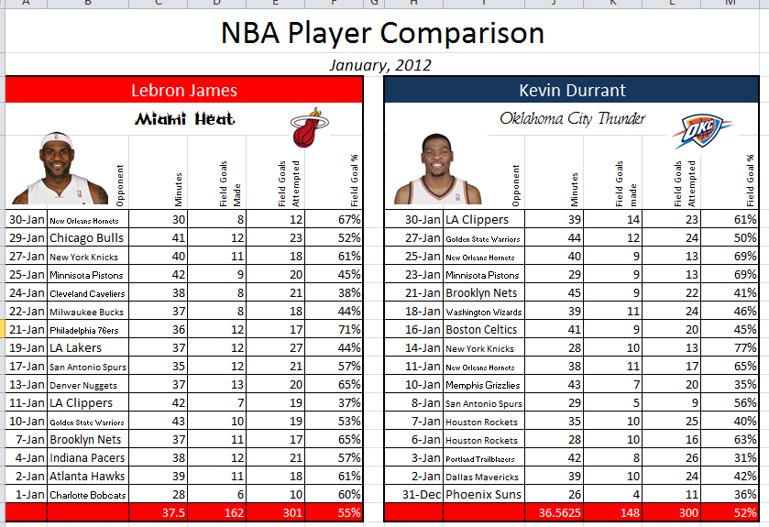
  - If it does, you are ready to print! Print to the black and white printer.

