Digital Literacy
Assignment 1

- Open a new, blank power point.
- SLIDE 1 – Title Page
  - Organize this page how you wish. It must have, however, the following elements:
    - Title – You choose the title, but you can use words like “Choose Your Own Adventure” “Episode 1” and then a name of your particular story.
    - Subtitle – Make sure you put your first and last name in the subtitle section
    - Background – Use any background you choose but do NOT leave it white.
    - You may add sound , color, and animations if you like.
- SLIDE 2 – Create ONE new slide.
  - At the top, type the information for your first decision. Ex: It’s Billy’s first day of school.
  - Go to Insert>Shape. Choose a shape that you want to use for your Decision 1 button. Choose a shape, and then draw it on your screen at the bottom of the page.
    - Use the Drawing Tools option to change the button to the look you want.
  - Go to Insert>Text Box. Draw a text box next to your button. In the text box, type the first choice. Follow the same steps to create a second decision.
  - Draw a new button shape. With button highlighted, type “Start Again.”
    - Click on the button so that the button is highlighted and not just the words. Right click and choose Hyperlink from the list.
    - Choose Place in this Document. From the list, pick your first, title slide. Click ok.
      - You have now created a working button on your slide show!
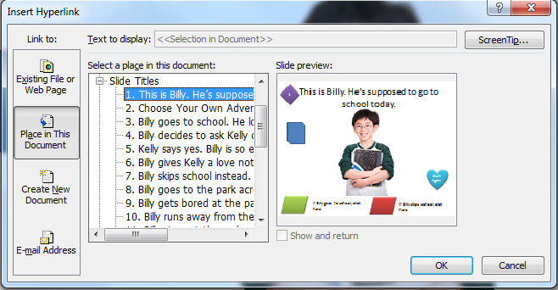
    - If you would like to number each slide, as in the example (the purple diamond) you may add this but it is not required. It may make it easier for you as you create the rest of the slideshow.
- ALL SLIDES – On your slide sorter, make sure you have Slide 2 highlighted. Then do CTRL+C to copy, and then CTRL+V to paste. Do 13 more times!
  - Now go through each of your copies slides and change the titles to the name of each of your future slides from the web page. You will go back and edit each slide, but now your buttons are all in place.
- SLIDE 3 – Slide 3 should be the first of two decisions from slide 2. Go back to slide 2 and click on the 1st decision button. Hyperlink it to slide 3. Fill in the story on slide 3 as you choose.
- Finish the rest of the power point in this manner, making sure that each story line has a direction, and adding hyperlinks on each decision.
- When you have a final slide with a story ending, delete the two decision buttons and just have the start again button. On all other decision slides, delete the start over button. It should only appear when a story string has ended.

Requirements:

- Your story can be about anything you choose. Be creative! Just be sure that you are also school appropriate.
- Use pictures from Clipart and the internet to tell your story. Use Remove Background if needed on those pictures. You may copy and paste them over and over again if they are being re-used on different slides.
- There must be at least ONE sound somewhere in your Power Point or you will lose points. You can do more than one sound if you like.
- You may want to keep your background white on all the slides except your title, just for ease with working with pictures. But you can color your backgrounds if you want.
- You must have at least ONE of each type of animation: Entrance, Exit, Emphasis, and Motion Path.

